**User Acceptance Testing (UAT) Template**

|  |  |
| --- | --- |
| Date | 6 March 2025 |
| Team ID | SWTID1741257978145975 |
| Project Name | Cook Book |
| Maximum Marks |  |

**Project Overview**

* Project Name: CookBook
* Description: A React-based virtual kitchen assistant that helps users search, filter, and save recipes using a third-party API. Features include ingredient-based search, meal categorization, nutritional details, and an intuitive UI.
* Version: v1.0
* Testing Period: March 1, 2025 – March 8, 2025

Testing Scope

✅ Features to be Tested:

* Home Page & Navigation
* Recipe Search & Discovery
* API Integration for Recipe Data
* Filtering by Ingredients, Cuisine, and Cooking Time
* Viewing Recipe Details (Instructions & Nutritional Info)
* UI/UX Testing (Responsiveness & Styling)
* Error Handling & Performance Testing

📌 User Stories to be Tested:

* Searching & Viewing Recipes
* Filtering by Ingredients, Cuisine, & Dietary Preferences
* Displaying Recipe Details (Step-by-Step Instructions & Nutrition)
* Ensuring Responsive UI (Mobile, Tablet, Desktop)
* Handling API Errors Gracefully

**Test Cases**

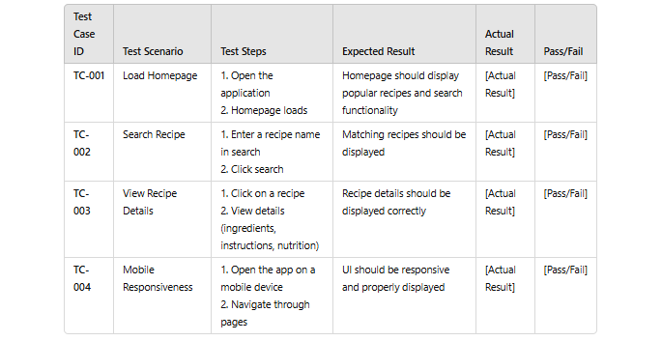

**Bug Tracking**

